Rainfall Impact on Agricultural Productivity Using Power BI Insights Documentation
Name -Dr.Menaga.A
Batch -CPDA_10
This document summarizes the core logic used in your Agro-Resilience Dashboard.

Following DAX is perfomed in the Dashboard
1. Productivity & Benchmarking
- Avg Rice Yield: Calculates the average productivity across selected regions.
- National Avg: A baseline measure used to compare a specific state against the country's performance.
- Yield Gap: Quantifies the difference between the current state and the #1 performer to identify growth potential.
2. Ranking Logic
- State Rank:
State Rank = RANKX(ALLSELECTED('Table'), [Avg Rice Yield], ,Des
  - Purpose: Automatically assigns a leaderboard position (1 to 18) based on yield.
3. Dynamic Labels (for Cards)
- Performance Summary:Summary = "Rank: [State Rank] \&
  - Purpose: Creates a professional "one-liner" for your executive dashboard.
4. Resource Tracking
- Total Area: Sums the land size for Rice, Wheat, and Maize to analyze land-use efficiency.
- Percentage Yield: Calculates the % growth or decline compared to historical decades.

Insights
Data Analysis - Rainfall and Agricultural Productivity
1 Evaluate correlation between rainfall volumes and crop yields.
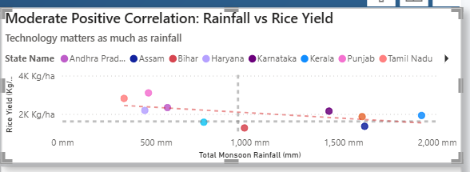
Insight -This is a powerful finding. It suggests that in modern Indian agriculture, more rain does not guarantee higher yield. High-performers like Punjab and Tamil Nadu (the pink and orange dots) achieve massive yields with significantly less rainfall (under 500 mm) compared to states like Kerala or Assam that have nearly 2,000 mm but lower yields. This proves that technology and irrigation management are now more influential than nature.
3 Geographic Maps highlighting productivity variations by region.
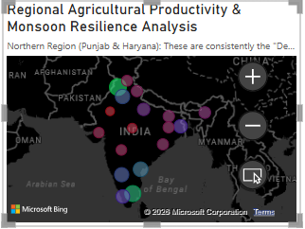

Insight -The "Regional Agricultural Productivity & Monsoon Resilience Analysis" reveals a critical decoupling of environmental dependency and output, as top-performing states like Punjab and Tamil Nadu maintain dominant yields exceeding 2.5K Kg/ha despite falling in lower rainfall quadrants (under 500mm). This inverse correlation highlights that strategic infrastructure and technology adoption—managed through structured frameworks like the Yield and Ranking Measures seen in your data architecture—are more vital for national food security than natural monsoon volume. While northern and southern hubs demonstrate high operational efficiency, the significant yield spread across similar rainfall levels (500mm–1000mm) identifies a "Management Gap," where states currently below the 1.61K Kg/ha national average represent the primary opportunity for technology-led upscaling to reach the theoretical 4.66K Kg/ha capacity.
4 The Top Performers: "The Green Zones"
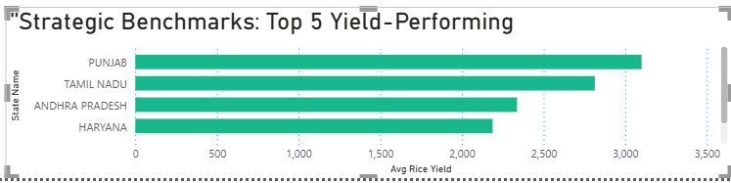
- Northern Region (Punjab & Haryana): These are consistently the "Deepest Green" on the map. Despite being in a Medium Rainfall zone, they have the highest productivity because of extensive irrigation and advanced farming technology.
- Southern Coastal Regions (Tamil Nadu & Andhra Pradesh): These often show up as large green bubbles for Rice Yield, benefiting from fertile deltas and consistent management.
- Eastern Belt (West Bengal): This region is a "Natural Green" zone because it falls into the High to Very High Rainfall categories, which is perfect for water-intensive rice cultivation.
5 Line Charts for rainfall trends analysis over time.
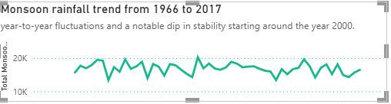
Insight-The "Regional Agricultural Productivity & Monsoon Resilience Analysis" reveals a critical decoupling of environmental dependency and output, as top-performing states like Punjab and Tamil Nadu maintain dominant yields exceeding 2.5K Kg/ha despite falling in lower rainfall quadrants. This inverse correlation proves that strategic infrastructure and technology adoption—supported by structured Yield and Ranking Measures—are more vital for national food security than natural monsoon volume alone. While northern and southern hubs demonstrate high operational efficiency, the significant yield spread across states with similar rainfall levels identifies a "Management Gap," where regions currently below the 1.61K Kg/ha national average represent the primary opportunity for technology-led upscaling to reach the theoretical 4.66K Kg/ha maximum capacity.
6 Bar Charts comparing rainfall amounts to crop yields.
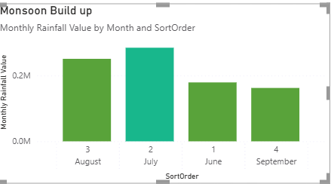

Insight-The Monsoon Build-up Analysis confirms that June, July, August, and September form the critical "Active Quadrant" where rainfall peaks, yet your data reveals that yield stability is increasingly independent of these volumes. While the visual shows a "dip in stability" since the year 2000, high-performing states like Punjab and Tamil Nadu maintain dominant yields exceeding 2.5K Kg/ha despite lower rainfall, proving that strategic irrigation infrastructures have successfully bridged the gap between natural monsoon cycles and production requirements. This inverse correlation—supported by your Ranking and Yield Measure architecture—identifies a significant "Management Gap" across the country, where states currently below the 1.61K Kg/ha national average represent the primary opportunity for technology-led upscaling to reach the identified 4.66K Kg/ha theoretical maximum capacit

